941-23 guruh talabasi Shonazarov Anvarbekning Mobil ilovalarni ishlab chiqish fanidan bajargan 9-amaliyot ishi

Flutter frameworkidan foydalangan holda ko'p funksiyali mobil ilova ishlab chiqish (REST API, ma'lumotlar bazasi va foydalanuvchi interfeysi integratsiyasi)

Ko'p funksiyali mobil ilova tuzilishi
Mobil ilova educator roli uchun uch asosiy bo'limdan iborat: Dashboard, Davomat va Vasiylar. Navigatsiya pastki NavigationBar orqali boshqariladi.
class HomeScreen extends StatefulWidget {
const HomeScreen({super.key, required this.session});
final AppSession session;
@override
State<HomeScreen> createState() => _HomeScreenState();
}
class _HomeScreenState extends State<HomeScreen> {
int _index = const int.fromEnvironment('INITIAL_TAB', defaultValue: 0);
@override
Widget build(BuildContext context) {
final destinations = <_Destination>[
_Destination(
'Dashboard',
Icons.dashboard_outlined,
DashboardPage(session: widget.session),
),
_Destination(
'Davomat',
Icons.fact_check_outlined,
AttendancePage(session: widget.session),
),
_Destination(
'Vasiylar',
Icons.contact_phone_outlined,
GuardiansPage(session: widget.session),
),
];
return Scaffold(
appBar: AppBar(
title: Text(destinations[_index].label),
actions: [
Padding(
padding: const EdgeInsets.symmetric(horizontal: 8),
child: Center(child: Text(widget.session.username)),
),
IconButton(
tooltip: 'Chiqish',
onPressed: widget.session.logout,
icon: const Icon(Icons.logout),
),
],
),
body: destinations[_index].page,
bottomNavigationBar: NavigationBar(
selectedIndex: _index,
onDestinationSelected: (value) => setState(() => _index = value),
destinations: [
for (final item in destinations)
NavigationDestination(icon: Icon(item.icon), label: item.label),
],
),
);
}
}
1-rasm. Dashboard ekrani
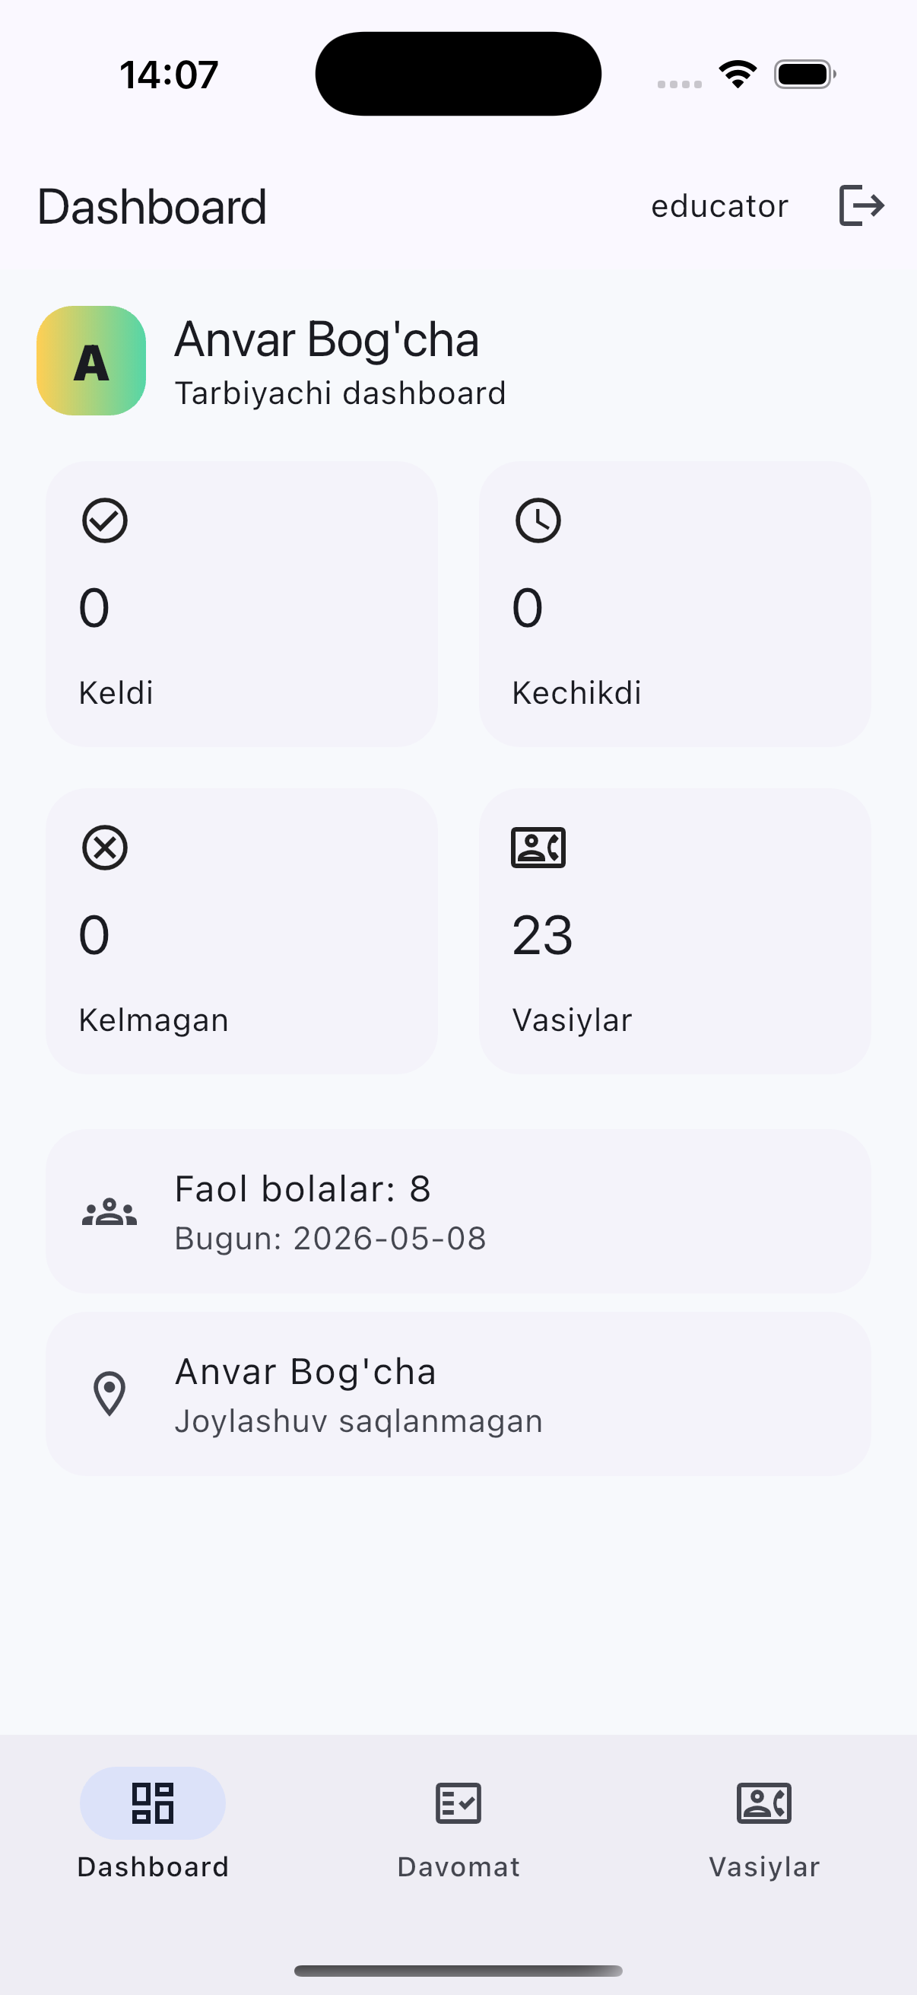

Davomat funksiyalari
Davomat ekranida sana, guruh, holat va bola ismi bo'yicha filterlash mavjud. Tarbiyachi tezkor tugmalar orqali bolani keldi, kechikdi, kelmagan, yarim kun yoki kutilmoqda holatlariga o'tkazishi mumkin.
class AttendancePage extends StatefulWidget {
const AttendancePage({super.key, required this.session});
final AppSession session;
@override
State<AttendancePage> createState() => _AttendancePageState();
}
class _AttendancePageState extends State<AttendancePage> {
final _search = TextEditingController();
DateTime _date = DateTime.now();
String _classroom = '';
String _status = '';
late Future<_AttendanceScreenData> _future = _load();
@override
void dispose() {
_search.dispose();
super.dispose();
}
Future<_AttendanceScreenData> _load() async {
final attendance = await widget.session.api.attendance(
date: _date,
classroom: _classroom,
status: _status,
query: _search.text,
);
final classrooms = await widget.session.api.classrooms();
return _AttendanceScreenData(attendance, classrooms);
}
Future<void> _refresh() async {
setState(() => _future = _load());
await _future;
}
Future<void> _pickDate() async {
final picked = await showDatePicker(
context: context,
initialDate: _date,
firstDate: DateTime(2020),
lastDate: DateTime(2100),
);
if (picked != null) {
setState(() {
_date = picked;
_future = _load();
});
}
}
Future<void> _mark(int id, String status) async {
try {
await widget.session.api.markAttendance(id, status);
if (mounted) _showSnack(context, 'Davomat yangilandi.');
await _refresh();
} on ApiException catch (error) {
if (mounted) _showSnack(context, error.message);
}
}
Future<void> _bulkMarkPresent() async {
if (_classroom.isEmpty) return;
try {
final data = await widget.session.api.bulkMarkPresent(
date: _date,
classroom: _classroom,
);
if (mounted) {
_showSnack(context, '${data['updated']} ta bola keldi deb belgilandi.');
}
await _refresh();
} on ApiException catch (error) {
if (mounted) _showSnack(context, error.message);
}
}
Future<void> _edit(
Map<String, dynamic> row,
List<Map<String, dynamic>> statuses,
) async {
final changed = await showModalBottomSheet<bool>(
context: context,
isScrollControlled: true,
builder: (context) {
return AttendanceEditSheet(
api: widget.session.api,
row: row,
statuses: statuses,
);
},
);
if (changed == true) await _refresh();
}
void _applyFilters() {
FocusManager.instance.primaryFocus?.unfocus();
setState(() => _future = _load());
}
void _clearFilters() {
_search.clear();
setState(() {
_classroom = '';
_status = '';
_future = _load();
});
}
@override
Widget build(BuildContext context) {
return FutureBuilder<_AttendanceScreenData>(
future: _future,
builder: (context, snapshot) {
if (snapshot.connectionState == ConnectionState.waiting) {
return const Center(child: CircularProgressIndicator());
}
if (snapshot.hasError) {
return _ErrorState(
message: snapshot.error.toString(),
onRetry: _refresh,
);
}
final data = snapshot.data!;
final attendance = data.attendance;
final rows = (attendance['results'] as List)
.cast<Map<String, dynamic>>();
final summary = attendance['summary'] as Map<String, dynamic>;
class AttendanceUpdateAPIView(APIView):
def patch(self, request, pk: int) -> Response:
denied = _require_educator(request)
if denied:
return denied
row = get_object_or_404(Attendance.objects.select_related("child", "child__classroom", "child__tariff"), pk=pk)
row_status = (request.data.get("status") or row.status).strip()
if row_status not in {value for value, _label in AttendanceStatus.choices}:
return Response({"detail": "Noto'g'ri holat."}, status=status.HTTP_400_BAD_REQUEST)
try:
check_in = _parse_time(request.data.get("check_in_time")) if "check_in_time" in request.data else row.check_in_time
check_out = _parse_time(request.data.get("check_out_time")) if "check_out_time" in request.data else row.check_out_time
except ValueError:
return Response({"detail": "Vaqt HH:MM formatida bo'lishi kerak."}, status=status.HTTP_400_BAD_REQUEST)
absence_reason = request.data.get("absence_reason", row.absence_reason)
notes = request.data.get("notes", row.notes)
absence_reason = "" if absence_reason is None else str(absence_reason).strip()
notes = "" if notes is None else str(notes).strip()
if check_in and check_out and check_out < check_in:
return Response({"detail": "Chiqish vaqti kirish vaqtidan keyin bo'lishi kerak."}, status=status.HTTP_400_BAD_REQUEST)
if row_status == AttendanceStatus.ABSENT and not absence_reason:
return Response({"detail": "Kelmagan holati uchun sabab kiriting."}, status=status.HTTP_400_BAD_REQUEST)
row.status = row_status
row.check_in_time = check_in
row.check_out_time = check_out
row.absence_reason = absence_reason
row.notes = notes
row.save(
update_fields=[
"status",
"check_in_time",
"check_out_time",
"absence_reason",
"notes",
"updated_at",
]
)
return Response({"attendance": serialize_attendance(row)})
2-rasm. Davomat ekrani va filterlar
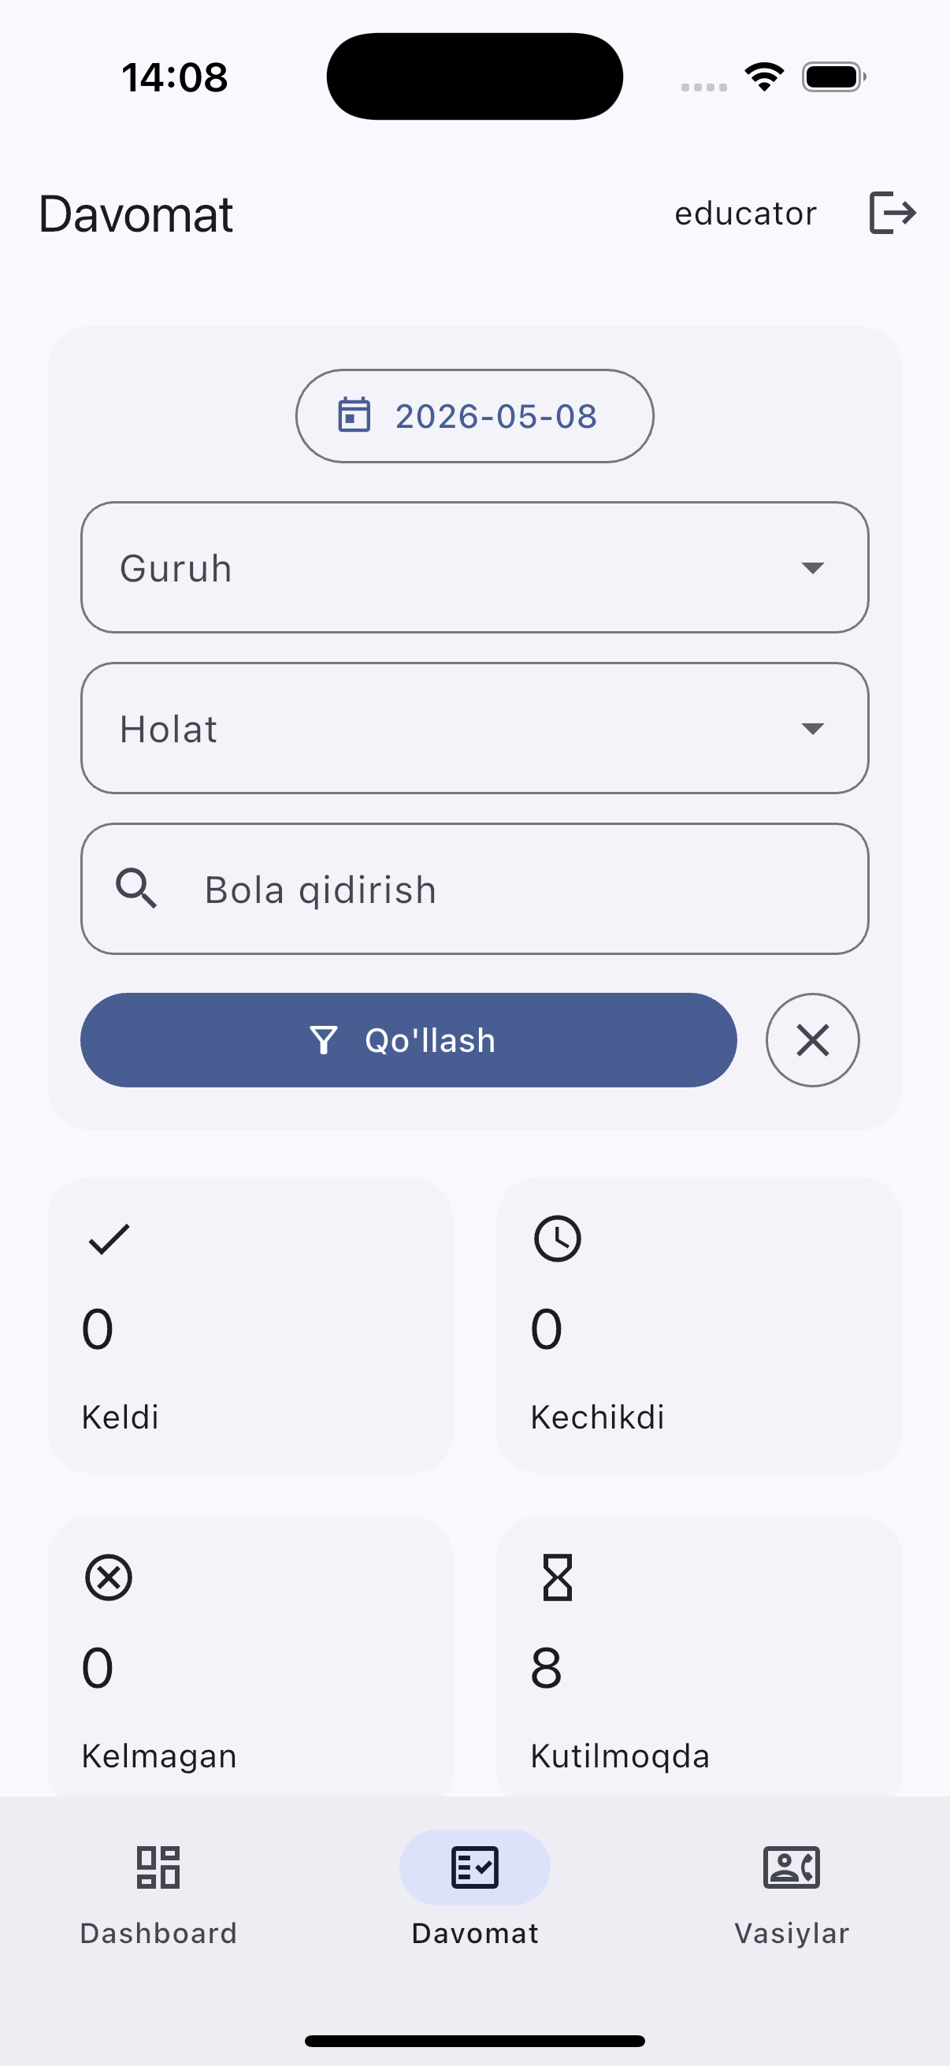

Vasiylar bilan ishlash
Vasiylar ekranida tarbiyachi bola yoki vasiy bo'yicha qidiruv qiladi. Telefon va email qiymatlarini clipboardga nusxalash uchun alohida tugmalar qo'shilgan.
class GuardiansPage extends StatefulWidget {
const GuardiansPage({super.key, required this.session});
final AppSession session;
@override
State<GuardiansPage> createState() => _GuardiansPageState();
}
class _GuardiansPageState extends State<GuardiansPage> {
final _search = TextEditingController();
late Future<Map<String, dynamic>> _future = _load();
@override
void dispose() {
_search.dispose();
super.dispose();
}
Future<Map<String, dynamic>> _load() {
return widget.session.api.guardians(query: _search.text);
}
Future<void> _refresh() async {
setState(() => _future = _load());
await _future;
}
void _applySearch() {
FocusManager.instance.primaryFocus?.unfocus();
setState(() => _future = _load());
}
void _clearSearch() {
_search.clear();
_applySearch();
}
Future<void> _copy(String value, String label) async {
await Clipboard.setData(ClipboardData(text: value));
if (mounted) _showSnack(context, '$label nusxalandi.');
}
@override
Widget build(BuildContext context) {
return FutureBuilder<Map<String, dynamic>>(
future: _future,
builder: (context, snapshot) {
if (snapshot.connectionState == ConnectionState.waiting) {
return const Center(child: CircularProgressIndicator());
}
if (snapshot.hasError) {
return _ErrorState(
message: snapshot.error.toString(),
onRetry: _refresh,
);
}
final rows = (snapshot.data!['results'] as List)
.cast<Map<String, dynamic>>();
return RefreshIndicator(
onRefresh: _refresh,
child: ListView(
padding: const EdgeInsets.all(16),
children: [
Row(
children: [
Expanded(
child: TextField(
controller: _search,
decoration: const InputDecoration(
labelText: 'Vasiy yoki bola qidirish',
prefixIcon: Icon(Icons.search),
),
textInputAction: TextInputAction.search,
onSubmitted: (_) => _applySearch(),
),
),
const SizedBox(width: 8),
IconButton.filledTonal(
onPressed: _applySearch,
icon: const Icon(Icons.search),
),
IconButton(
onPressed: _clearSearch,
icon: const Icon(Icons.clear),
),
],
),
const SizedBox(height: 16),
if (rows.isEmpty)
3-rasm. Vasiylar kontaktlari
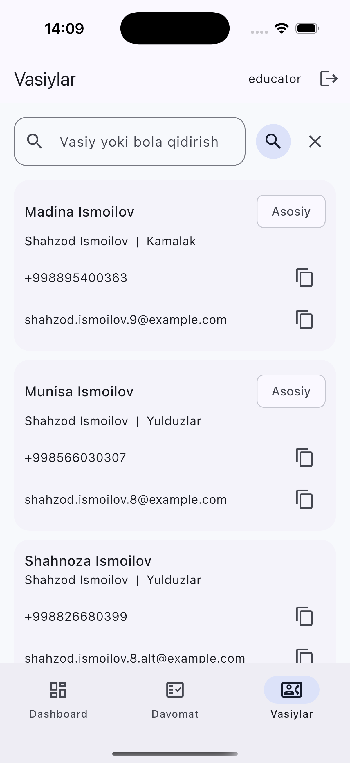

Xulosa
Ushbu amaliy ishda Anvar Bog'cha CRM loyihasi uchun mobil ilova, REST API, token autentifikatsiya, davomat va vasiylar bilan ishlash jarayonlari ko'rib chiqildi. Ilova iOS simulatorda ishga tushirilib, asosiy ekranlari tekshirildi.

